**ONLINE STORE (**E-COMMERCE**)**

**T. TARUN KUMAR**

**Requirements:**

• Software Used: Figma (Wireframing)

Power point (Sketching)

• Fonts Used: Times New Roman (For Subtitles and information)

Philosopher (For Titles)

**Design Inspiration:**

• Behance

• Pinterest

• Chrome Browse

**ABOUT US:**

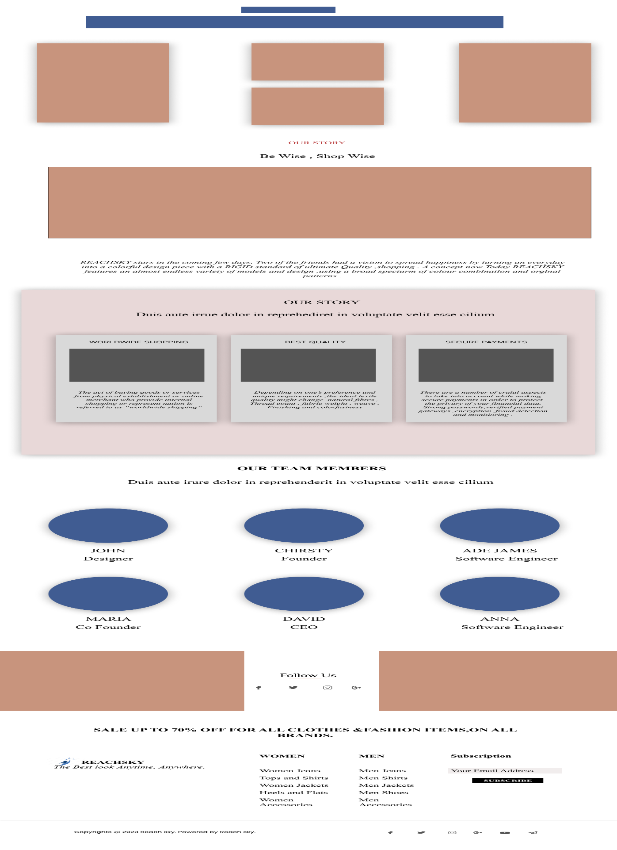

**CONTACT US:**

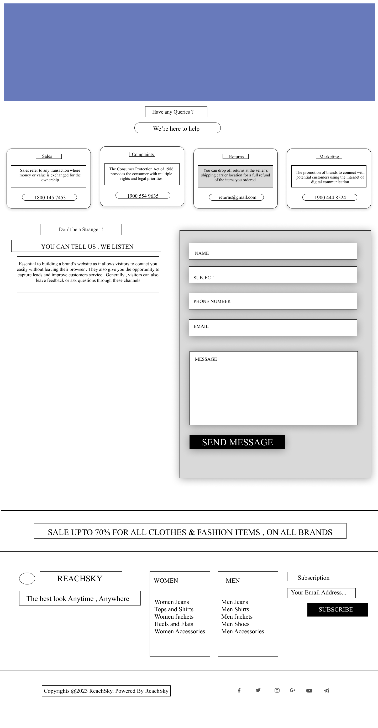

**PROFILE:**

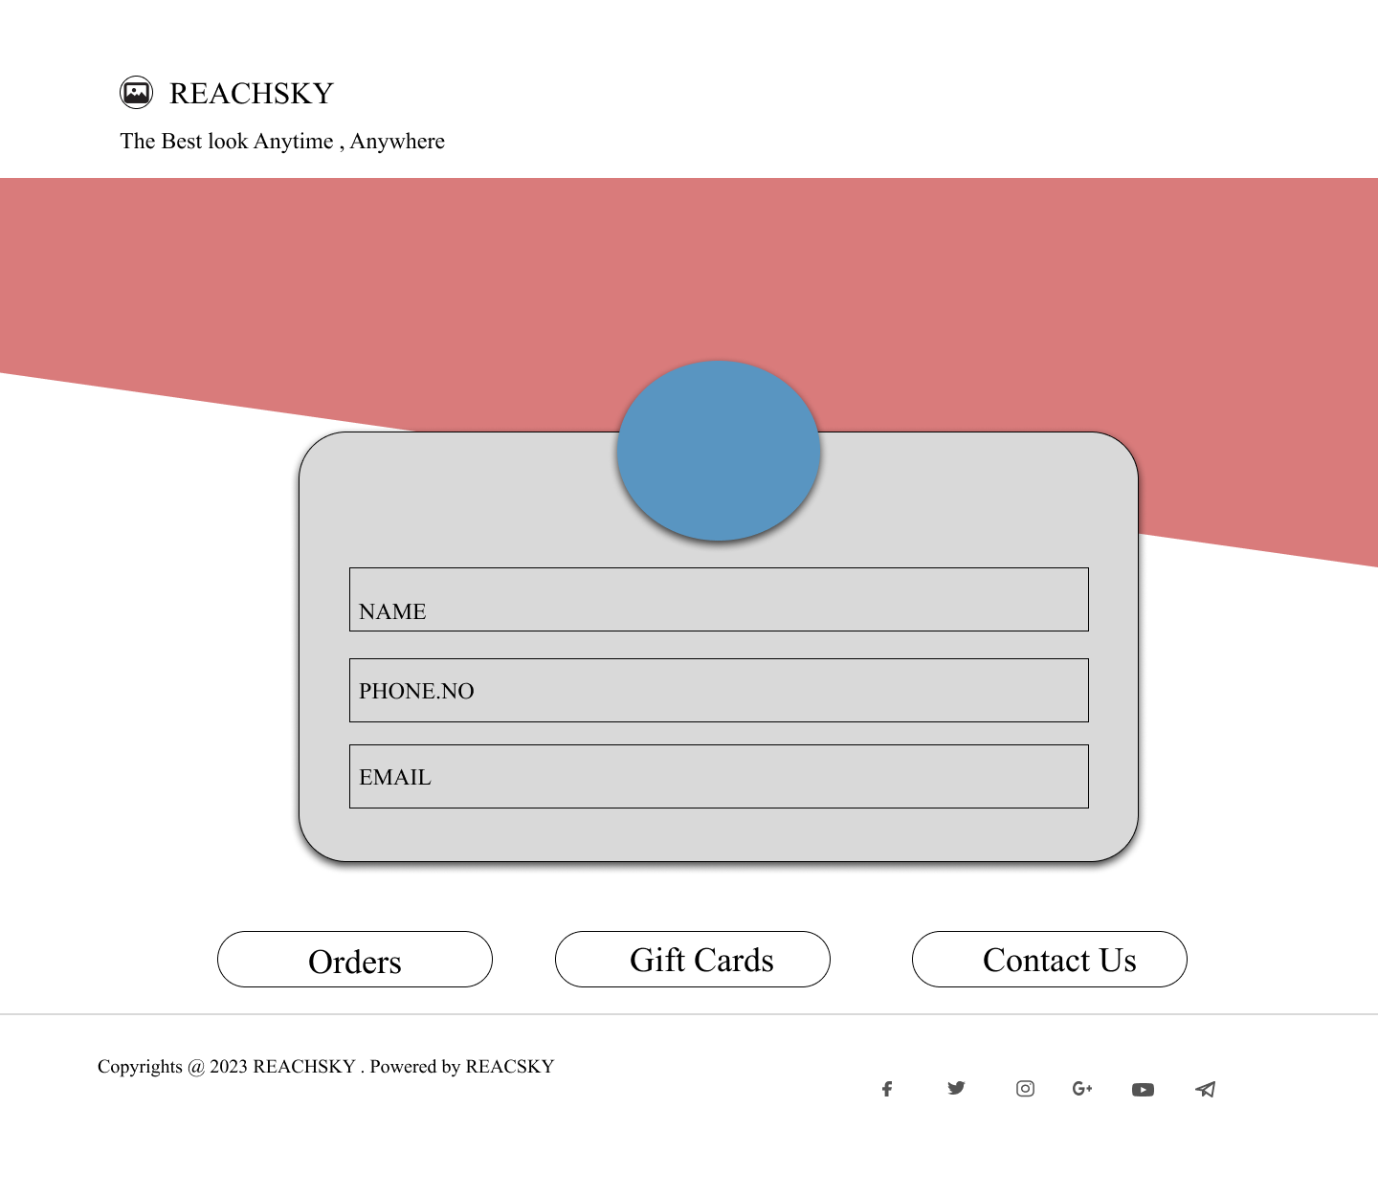

**ACCOUNT:**

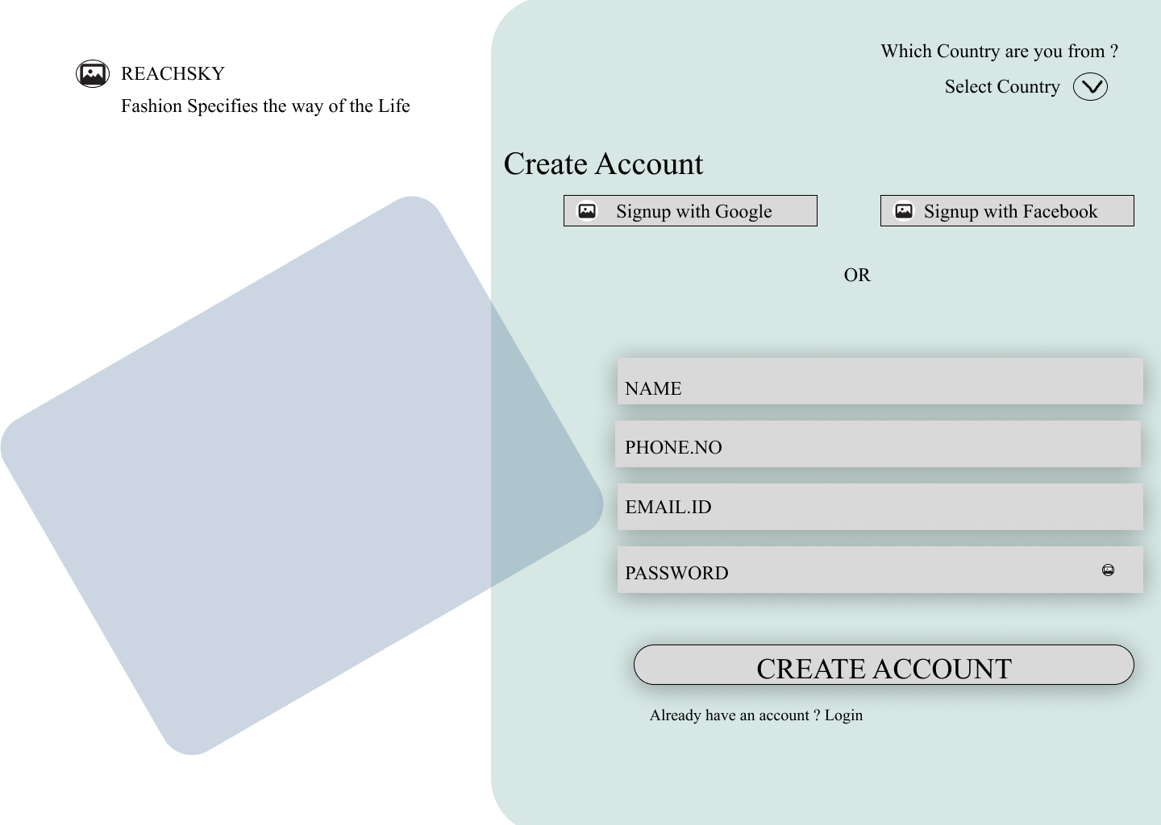

**OFFERS:**

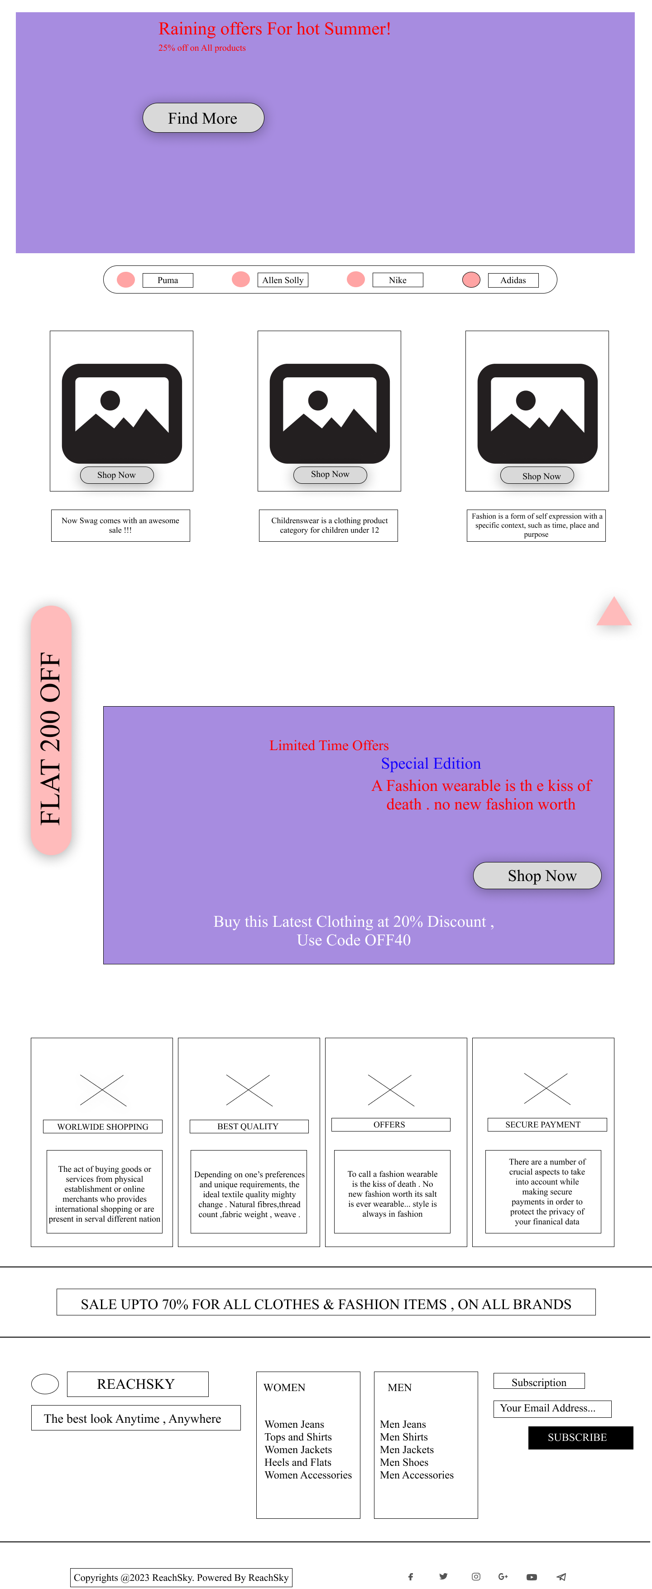

**SHOP NOW:**

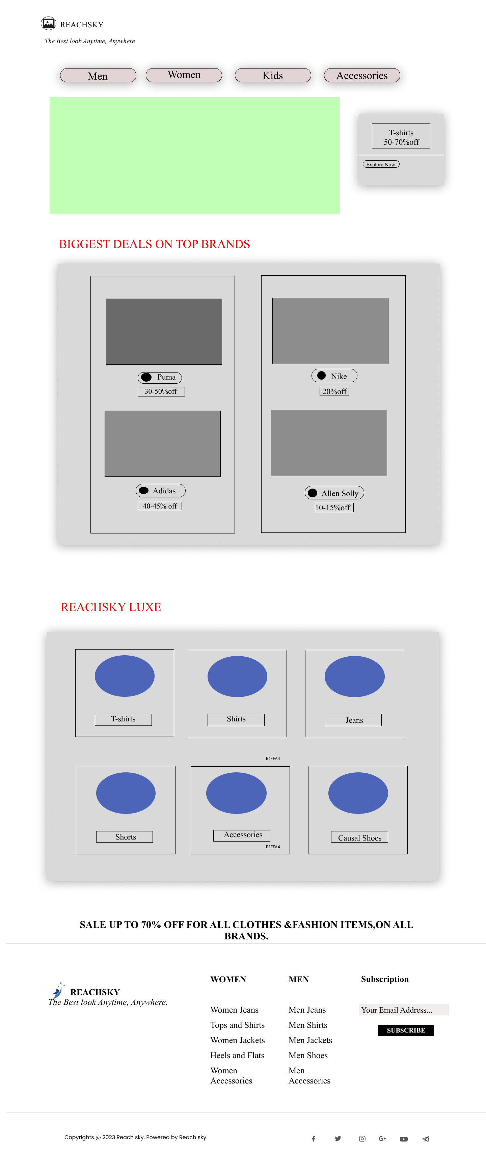

**DIGITAL SCREEN**

**HOME SCREEN:**

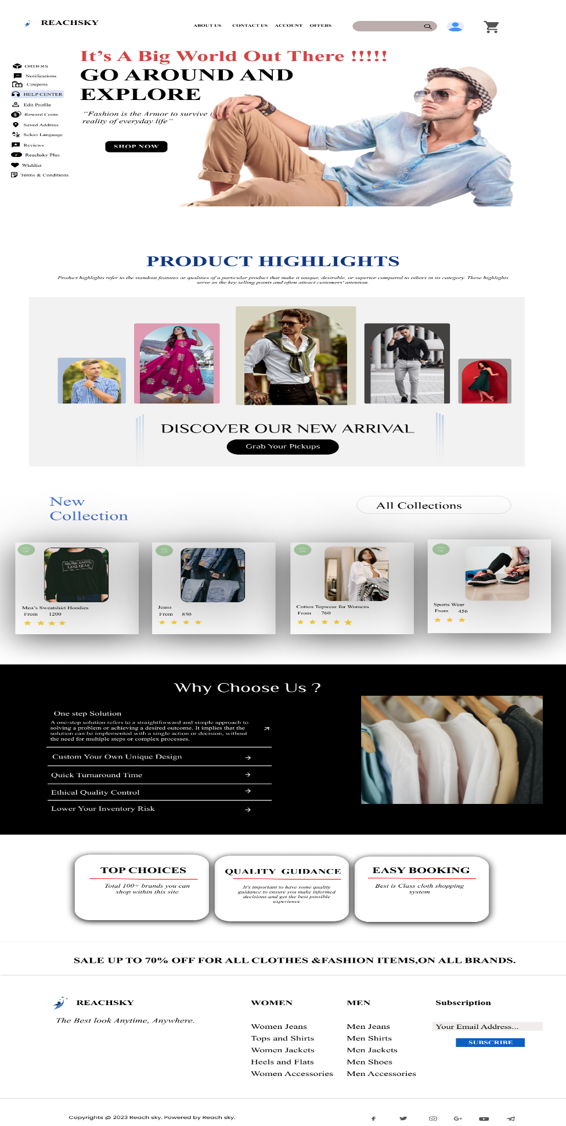

**ABOUT US:**

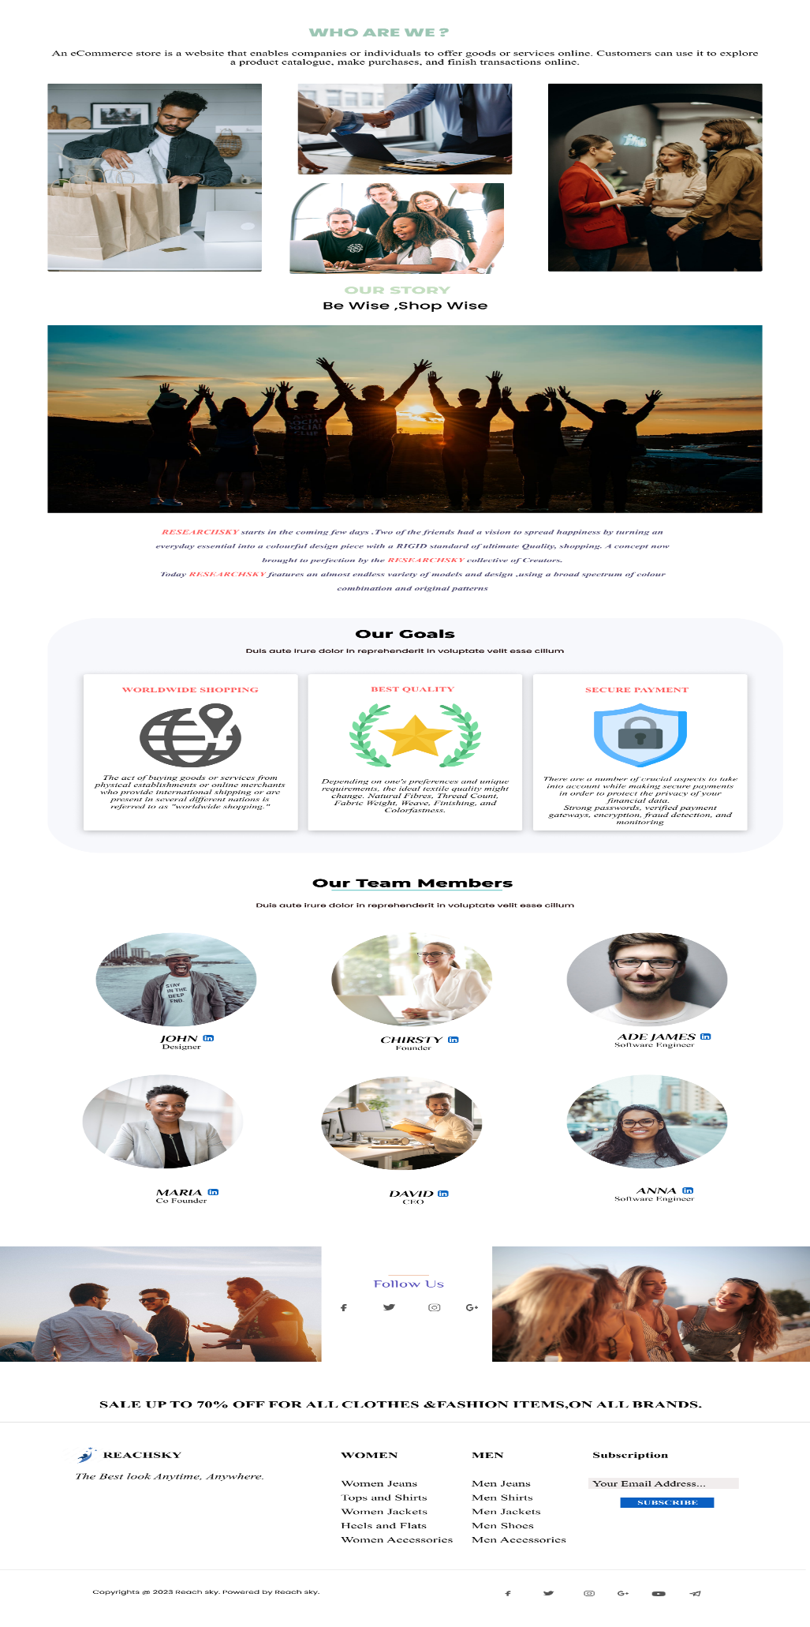

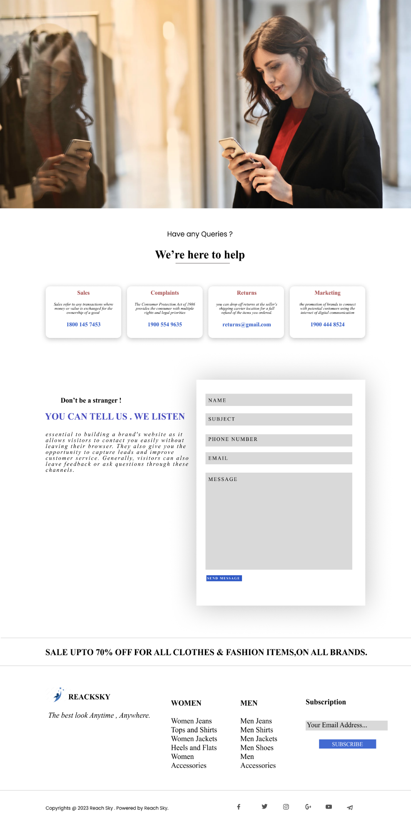**CONTACT US:**

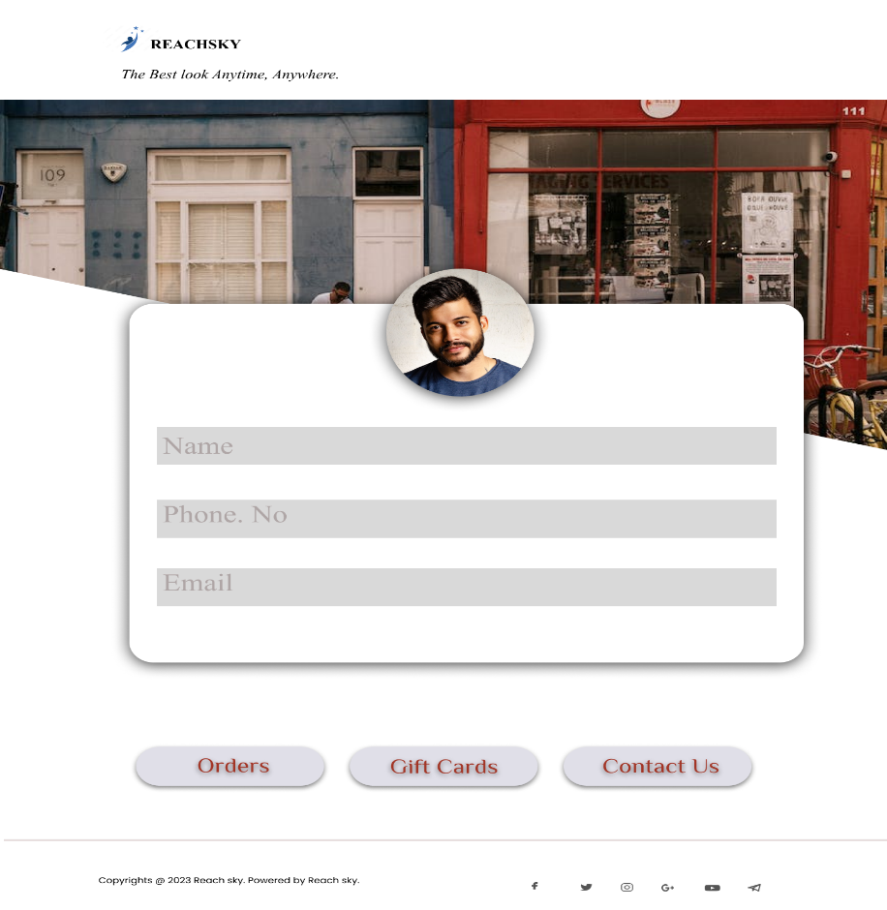**PROFILE:**

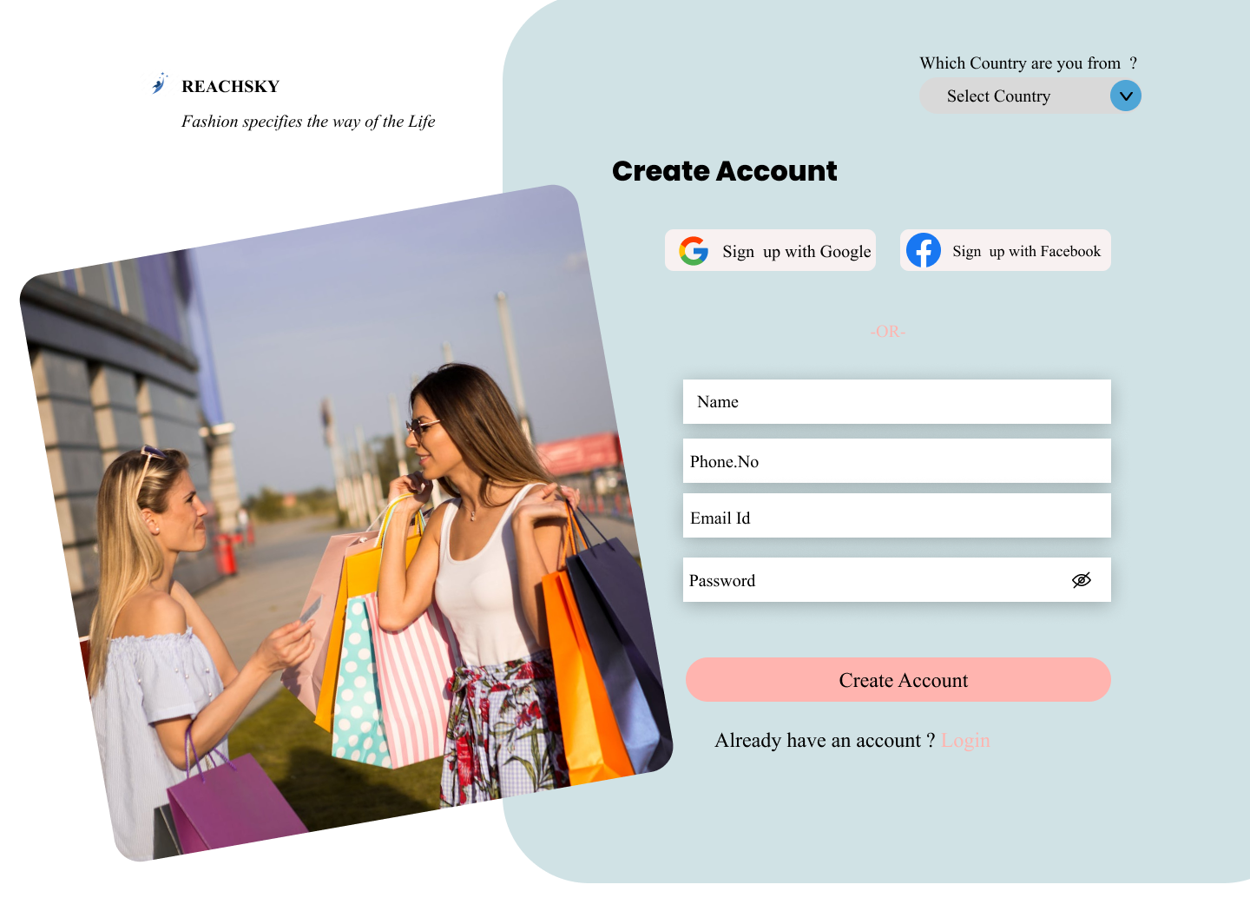**ACCOUNT:**

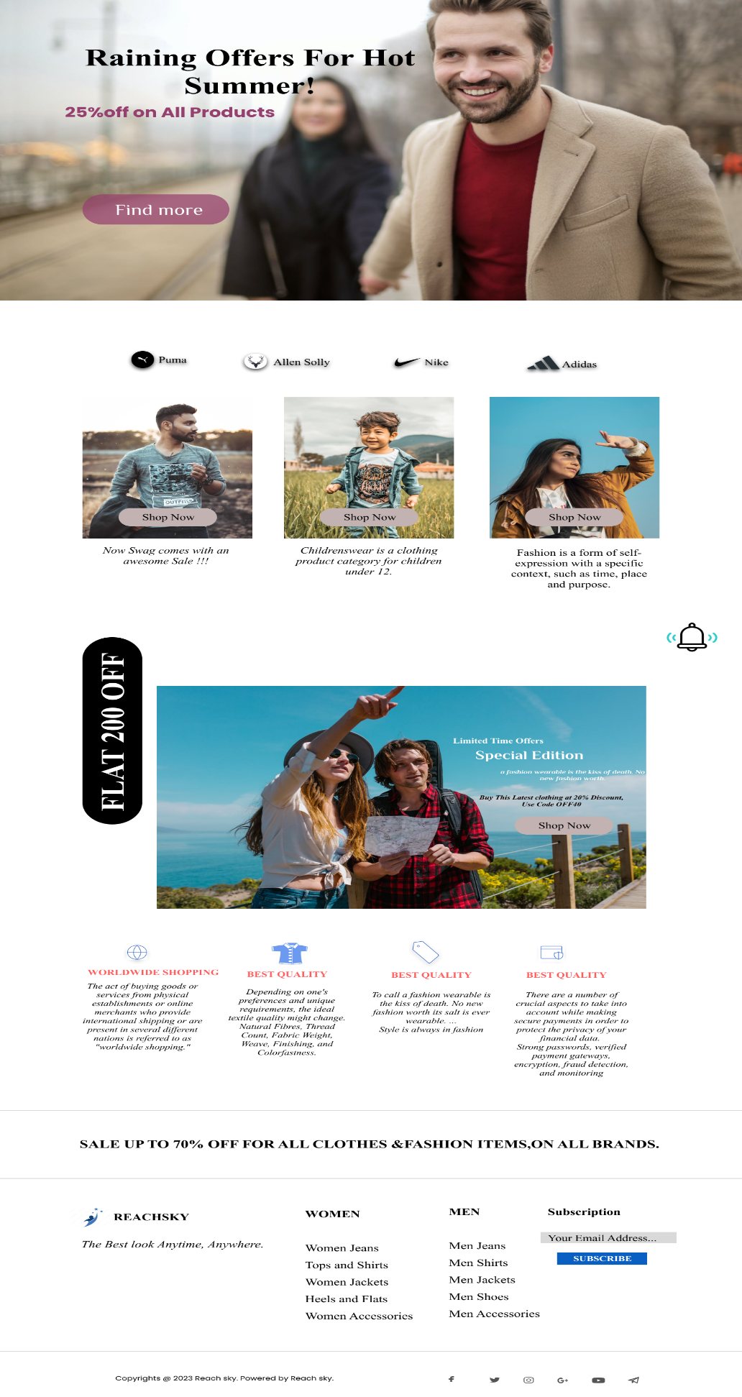**OFFERS:**

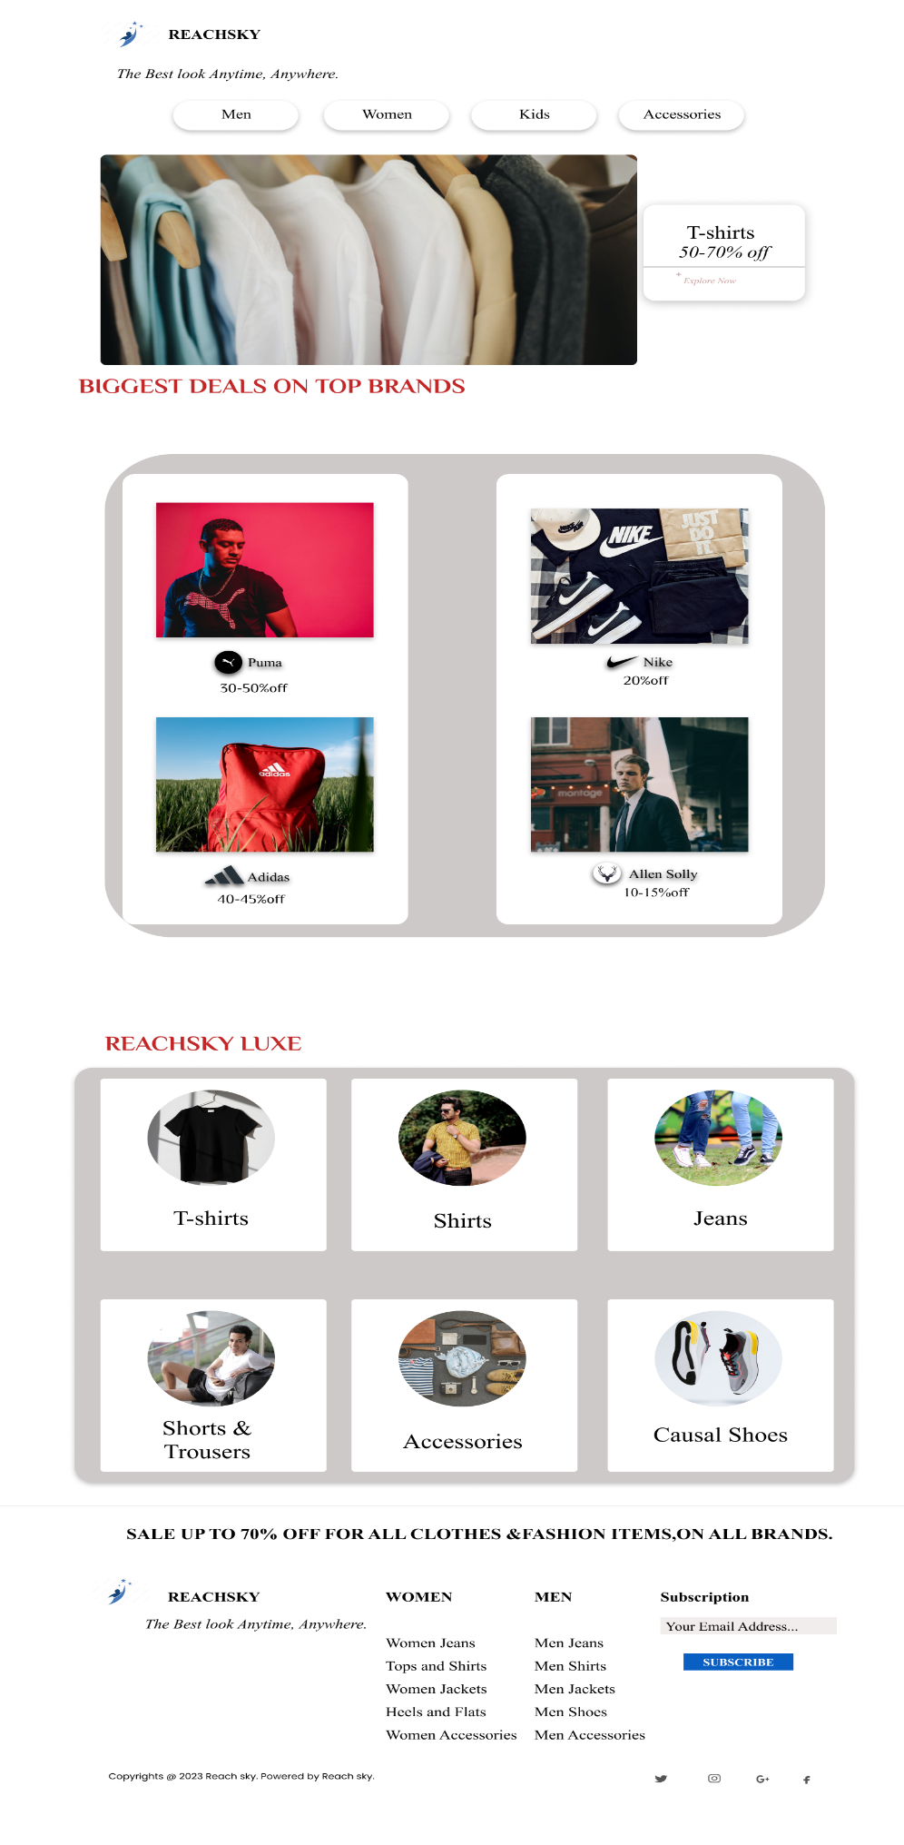**SHOP NOW:**

**DRIBBLE LINK:**  
  
https://dribbble.com/shots/22100517-E-commerce-Online-Shopping-Store